MISSION IMPOSSIBLE (MI)

Overview –

Our MI representatives can have all their day to day activities done without login to MI. That is, by using

Google Assistant!!!

For an example creating an appointment with a doctor while playing a game or finding the list of doctors in his car using NearMe or checking the list of calls for any particular month.

How to do that????!!!

Just take your phone or any voice device and say “Talk to my TestApp”.

Design Steps –

1. Login to API.AI -

* Agents are NLU(Natural Language Understanding) modules. The purpose of Agents is to transform natural user language into actionable data.

Create a new Agent in API.AI –

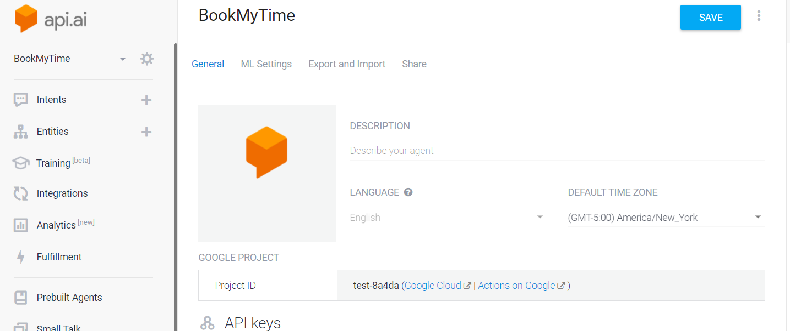

* Next step is to Create Entites – are enumerations (example – appointment with doctor in which mode – face to face or over the phone call). Entities are in alphanumebric combination.

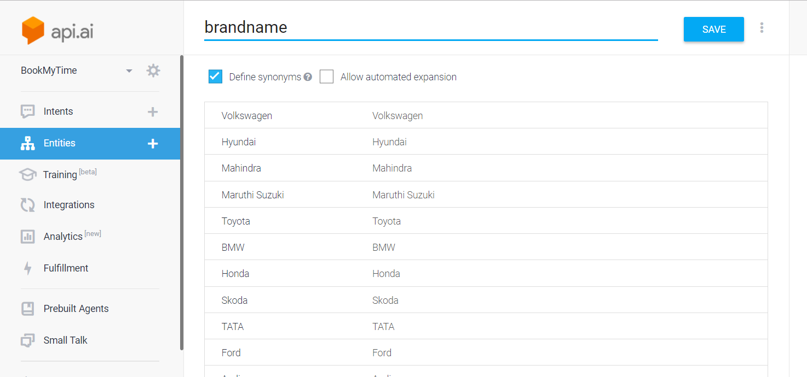

* Create Intents (intents are nothing but use cases or user actions). For example OrderStatus is an intent and the user query “show me order status for orderId”.

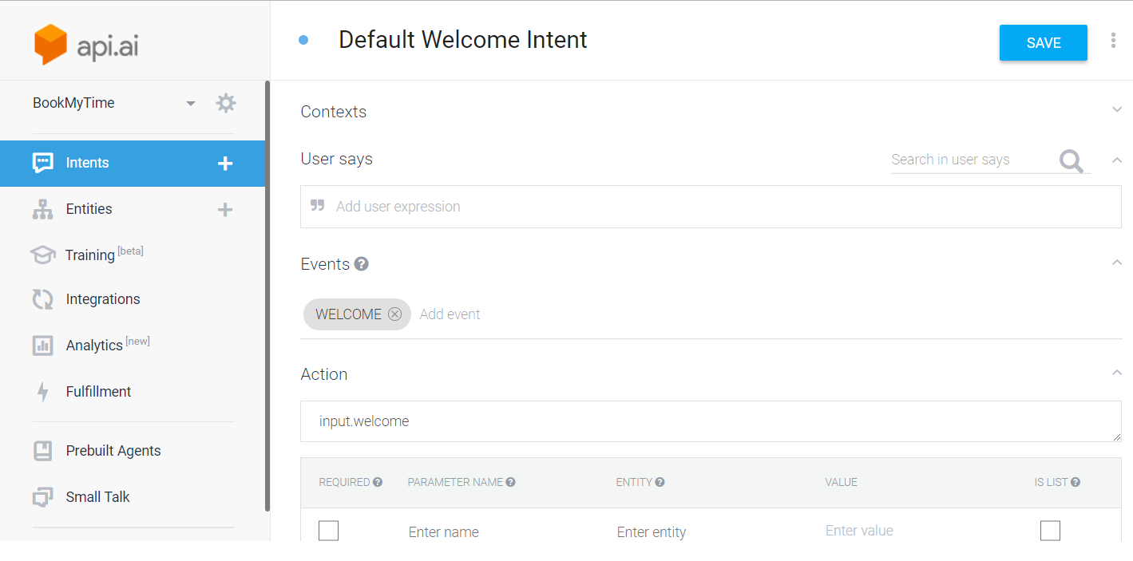

* As we are using NPM module, NPM module need to be installed in the project path using “npm-install”. The Package.Json contains the dependent library details.
* Create index.js which has functions to access the intents.
* Create a fulfillment, that is where we add a webhook url which will send the Json request to our MI application API endpoints and get the response to display to the end user/rep.

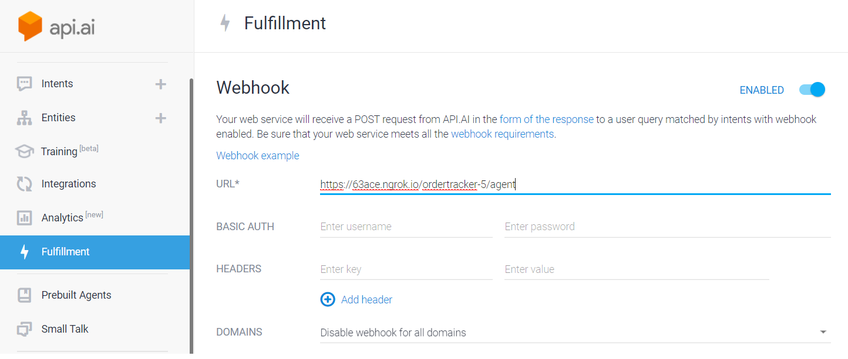

* Create/Add Integrations – Google Assistant

1. The API.AI uses Node.JS as a development platform.